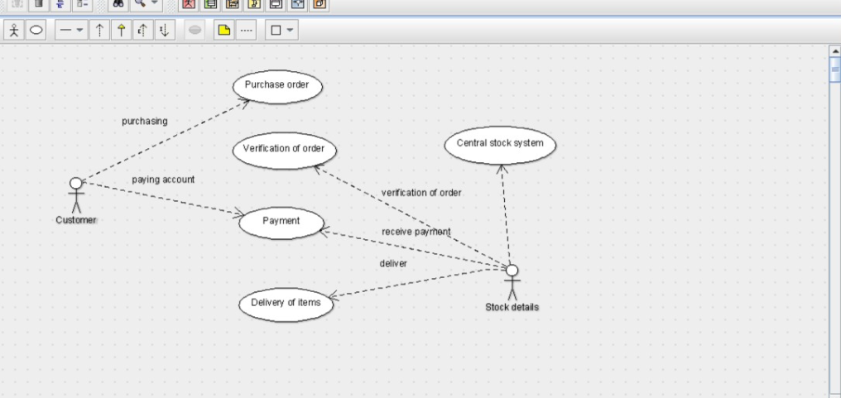USE CASE DIAGRAM

CLASS DIAGRAM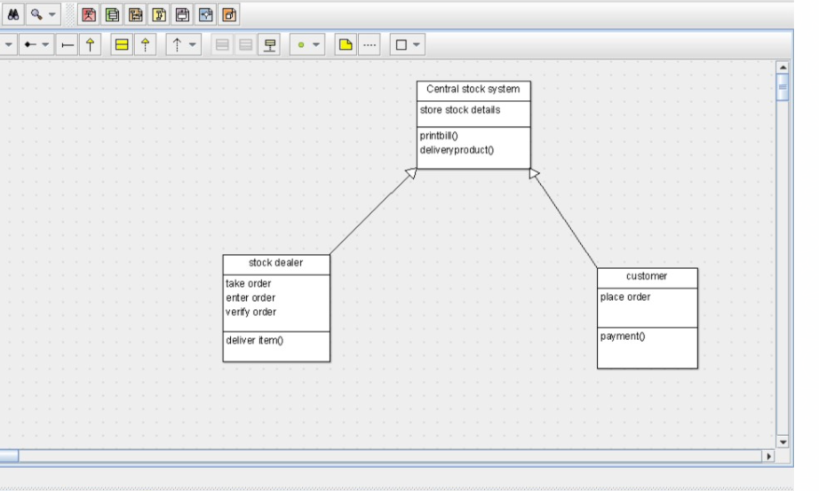

ACTIVITY DIAGRAM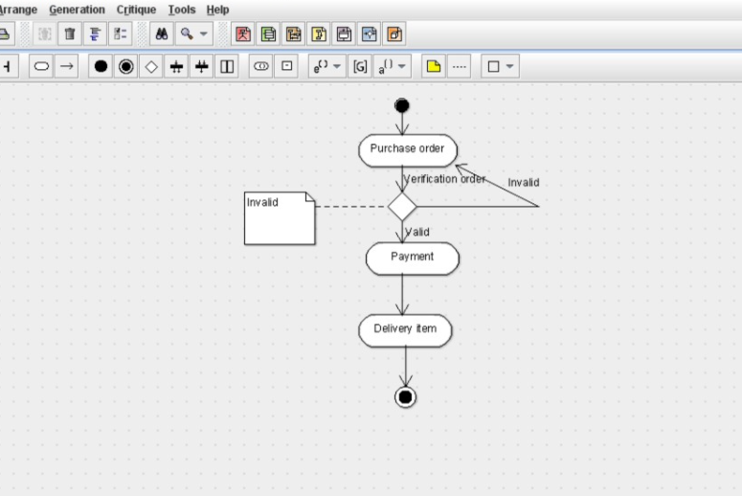

public class customer extends Central stock system {

public place order;

public void payment() {

}

}

Code 3

public class stock dealer extends Central stock system {

private take order;

public enter order;

public verify order;

public void deliver item() {

}

}public class Central stock system {

public store stock details;

public void printbill() {

}

public void deliveryproduct() {

}

}

SEQUENCE DIAGRAM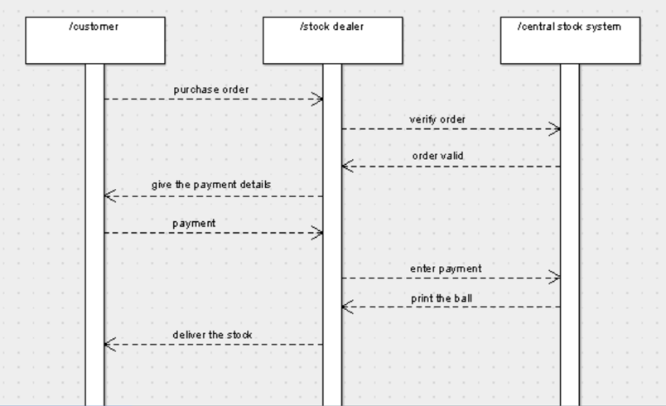

COLLABORATION DIAGRAM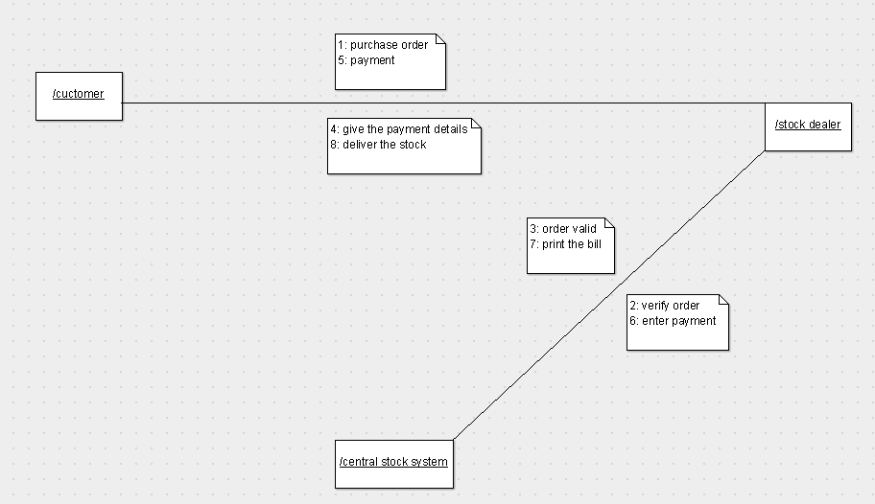

STATE CHART DIAGRAM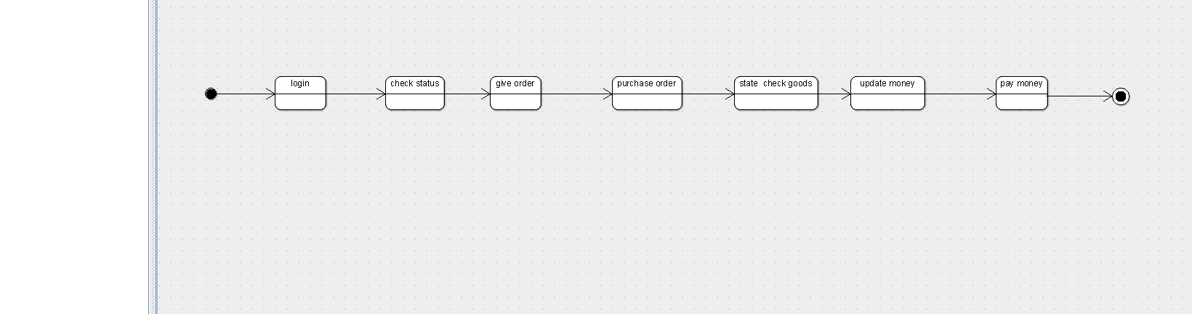

COMPONENT DIAGRAM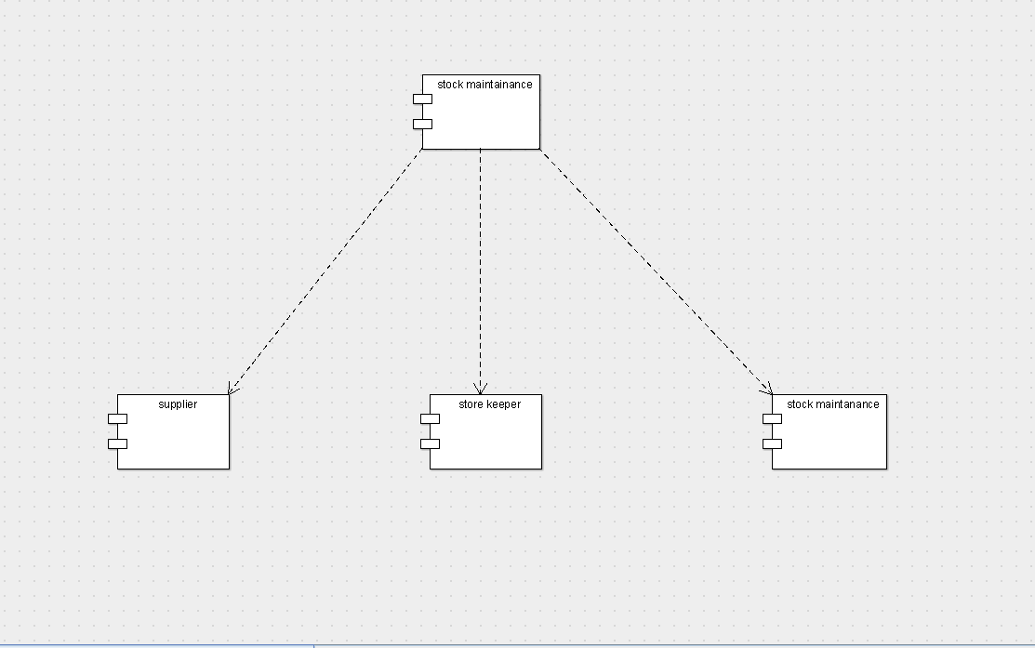

DEPLOYMENT DIAGRAM